**Module: 4- Linux server - Manage user and Groups and working with file systems**

**32. Manage Users and Groups**

Create User:

sudo useradd <username>

Delete User:

sudo userdel <username>

Create Group:

sudo groupadd <groupname>

Change Password:

sudo passwd <username>

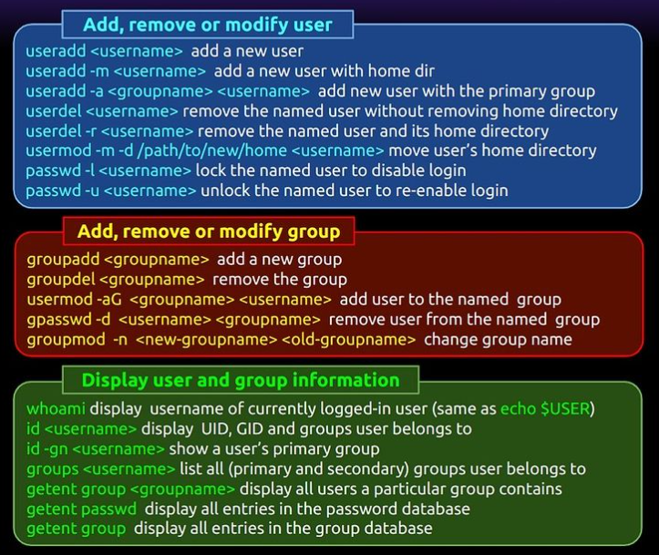

**33. Different Filesystem Types in Linux**

ext4 (Fourth Extended Filesystem):

Usage: Default filesystem for many Linux distributions.

Features:

Supports large files and volumes.

Journaling: Helps in quick recovery after a crash.

Extents: Improves performance by reducing fragmentation.

Backward compatibility with ext3 and ext2.

XFS:

Usage: High-performance filesystem, often used in enterprise environments.

Features:

Scalable: Handles large files and directories efficiently.

Journaling: Ensures data integrity.

Online defragmentation and resizing.

Btrfs (B-tree Filesystem):

Usage: Advanced filesystem with modern features.

Features:

Snapshots: Allows creating read-only or writable snapshots.

Subvolumes: Supports multiple subvolumes within a single filesystem.

Self-healing: Detects and repairs data corruption.

RAID support: Built-in support for RAID configurations.

ZFS (Zettabyte File System):

Usage: Known for data integrity and high storage capacities.

Features:

Data integrity: End-to-end checksumming to detect and correct data corruption.

Snapshots and clones: Efficiently create snapshots and clones of filesystems.

Pooled storage: Combines multiple devices into a single storage pool.

Compression: Supports transparent compression to save space.

ReiserFS:

Usage: Once popular for its efficiency and performance.

Features:

Efficient storage: Handles small files efficiently.

Journaling: Provides quick recovery after crashes.

Dynamic inode allocation: Allocates inodes dynamically, reducing wasted space.

FAT32:

Usage: Commonly used for USB drives and memory cards.

Features:

Compatibility: Supported by almost all operating systems.

Limitations: Maximum file size of 4GB and no journaling.

exFAT:

Usage: Extended FAT, used for flash drives and SD cards.

Features:

Large file support: Handles files larger than 4GB.

Compatibility: Supported by many operating systems, including Windows and macOS.

NTFS (New Technology File System):

Usage: Default filesystem for Windows.

Features:

Large file and volume support.

Journaling: Ensures data integrity.

Security: Supports file permissions and encryption.

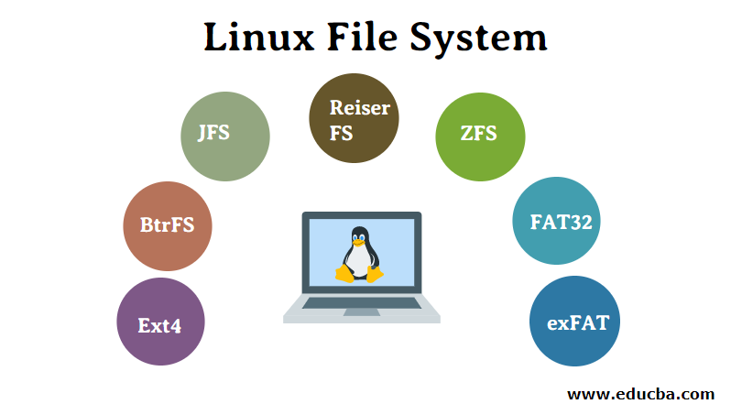

**34. File Permission Groups in Linux**

Owner: The user who owns the file.

Group: Users who are part of the file’s group.

Others: All other users.

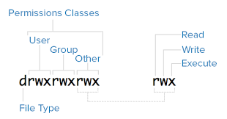

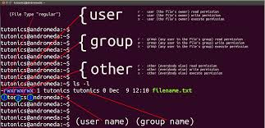

**35. Switch Desktop Environments**

Switching between desktop environments like KDE and GNOME involves a few steps. Here’s a detailed guide:

1. Install the Desired Desktop Environment

First, you need to install the desktop environment you want to switch to. For example, to install KDE or GNOME on Ubuntu, you can use the following commands:

Install KDE:

sudo apt install kde-plasma-desktop

Install GNOME:

sudo apt install gnome

2. Log Out of Your Current Session

After installing the new desktop environment, log out of your current session. This will take you back to the login screen.

3. Select the Desktop Environment

On the login screen, you will see a session menu (often represented by a gear icon or similar). Click on this menu to see a list of available desktop environments. Select the one you want to use (e.g., KDE or GNOME).

4. Log In

After selecting the desired desktop environment, log in with your user credentials. Your system will now start with the chosen desktop environment.

5. Switching from the Command Line (Optional)

If you prefer to switch desktop environments from the command line, you can use the update-alternatives command:

sudo update-alternatives --config x-session-manager

This command will present you with a list of installed desktop environments. You can select the one you want to use by entering the corresponding number1.

Example for Ubuntu/Debian:

Install KDE:

sudo apt install kde-plasma-desktop

Install GNOME:

sudo apt install gnome

Log Out and Select Session: On the login screen, click the session menu and choose the desired desktop environment.

Command Line Switch:

sudo update-alternatives --config x-session-manager

**36. Kinds of Permissions Under Linux**

Read ®: View file contents.

Write (w): Modify file contents.

Execute (x): Run the file as a program.

As we discussed file permissions.

**37. Different Modes in vi Editor**

Normal Mode: Default mode for navigation and commands.

Insert Mode: For inserting text.

Enter with i, a, o.

Visual Mode: For selecting text.

Enter with v, V, Ctrl+v.

Command Mode: For executing commands.

Enter with : .